 4th Floor, Legacy Towers

Kyadondo Road, Nakasero

and, Suite 267 Serena Conference Centre

PO Box 11644

Kampala, Uganda

**Bid-Securing Declaration**

Date: *16th March 2020*

Subject of procurement and Reference No.: ***UPF/SUPLS/19-20/CFC/00038***

To: **Uganda Police Force**

We, the undersigned, declare that:

1. We understand that, according to your conditions, bids must be supported by a Bid- Securing Declaration.

2. We accept that we will automatically be suspended for three years by the Authority from being eligible for bidding in any contract with the Government of Uganda*,* if we are in breach of our obligation(s) under the bid conditions, because we:

(a) have withdrawn our bid during the period of bid validity specified by us in the Bid Submission Sheet or

(b) having been notified of the acceptance of our bid by the Procuring and Disposing Entity during the period of bid validity fail or refuse to (i) sign the contract, (ii) fail or refuse to furnish the Performance Security in accordance with ITB Clause 43; or (iii) fail or refuse to accept the correction of our bid by the Procuring and Disposing Entity, pursuant to ITB Clause 31;

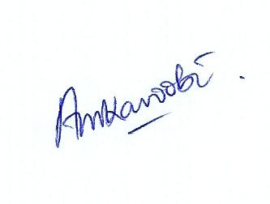3. We understand this Bid Securing Declaration shall cease to be valid if I/we are not the successful Bidder, upon the earlier of (i) the expiry of the notice of best evaluated bidder or (ii) upon the expiration of the validity of my/our bid on the ***12/06/2020***,

Signed:

In the capacity of *Director*

Name: *ALEX MUKAMA KAROOBI*

Duly authorized to sign the bid securing declaration for and on behalf of: *Masterlinks Uganda Limited*

Dated on: *16th day of March 2020*